WEB APPLICATION USING NODE RED :

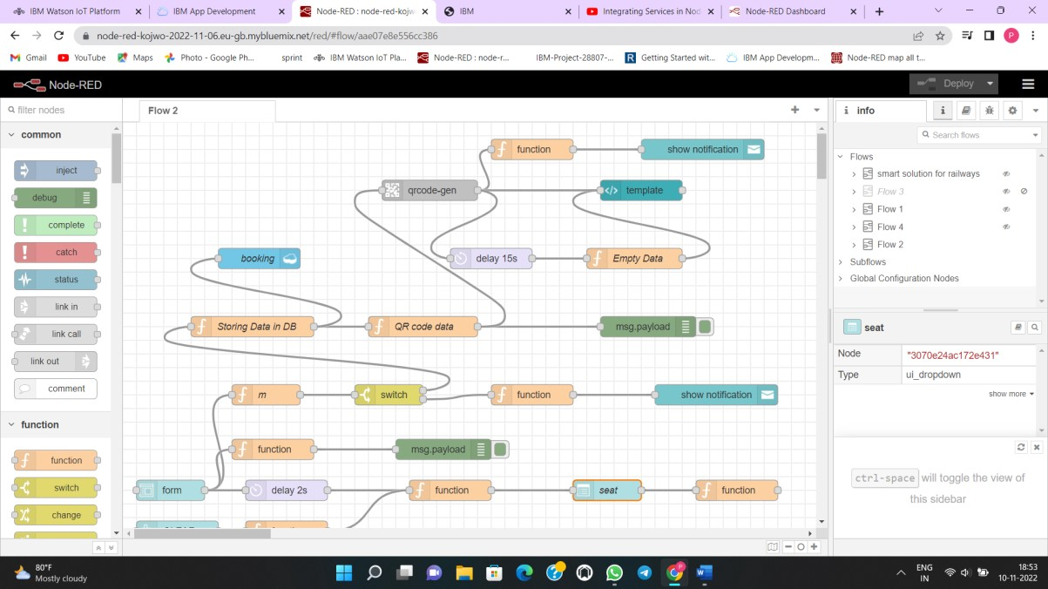

|  |  |
| --- | --- |
| TEAM ID | PNT2022TMID30896 |
| PROJECT NAME | SMART SOLUTIONS FOR RAILWAYS |

